6th Grade Math (10/02/2011)

If a certain kind of lemonade is made by mixing water and lemon juice in a ratio of 3¹/₂ cups of water for every ¹/₂ cup of lemon juice, how many cups of lemon juice will there be in 24 cups of lemonade?

The ratio of Sally’s age to Lucy’s age is 8 : 5. 30 years later, this ratio will be 6 : 5. How much older is Sally than Lucy now?

Peter is taking a True/False test. He only got 3 of the first 11 questions correct. What is the minimum total number of questions the test must have on it for Peter to still have a chance at getting 3/4 of the questions correct?

7th Grade Math (10/02/2011)

A telephone company charges x cents for the first minute of a call and charges for additional time at the rate of y cents per minute. If a certain call costs $5.55 and lasts more than 1 minute, which of the following expressions represents the length of the call, in minutes?

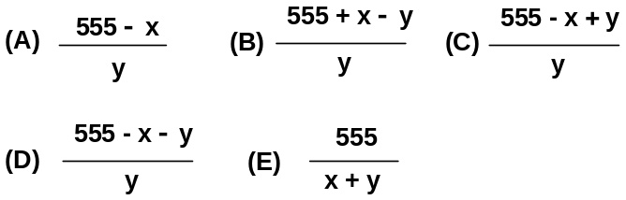

Three boxes A, B and C, had 260 ping pong balls. Lisa added some ping pong balls into box A and the number of ping pong balls in box A tripled. She took out half of the ping pong balls in box B and added 40 ping pong balls into box C. The ratio of the number of ping pong balls in boxes A, B and C became 6 : 4 : 5. Find the original ratio of the number of ping pong balls in boxes A, B and C.

When siblings Mik, Ike and Spike do chores around the house their parents pay them each different amounts of money. Ike always gets 20% more money than Spike, while Ike always gets 30% less money than Mike. If their parents decide to pay them $13.70 total, how much does Ike get paid?

